**UNIT 7**

**Convolution Neural Network For Image Classification**

| **7.1 Introduction to CNNs** |
| --- |
| **7.2 Image Classification** |
| **7.3 Object Detection** |

**7.1 Introduction to CNNs: Convolutional layers, pooling layers, fully connected layers**

What are Convolutional Neural Networks, ConvNets in short. Let’s start by looking at how a ConvNet looks!

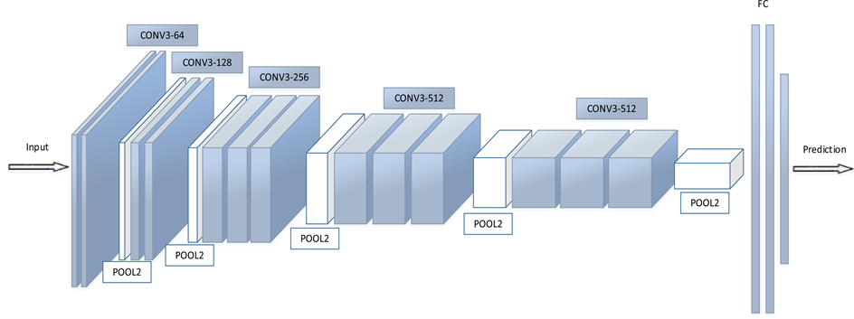

[Convolutional Neural Network](http://file.scirp.org/Html/4-7800353_65406.htm)

### **CNN Architecture and Importance of Each Layer**

A **Convolutional Neural Network (CNN)** is a type of deep learning model designed to process structured data like images and videos. Its architecture consists of several key layers, each with a specific role:

### **1. Input Layer**

* **Purpose**: Takes in the raw image data.
* **Example Input**: A 2D grayscale image (matrix of pixel values) or a 3D RGB image.
* **Importance**: Converts the image into a numerical format that the CNN can process.

### **2. Convolutional Layer**

* **Purpose**: Extracts features (edges, textures, shapes) by applying small filters (kernels) over the input.

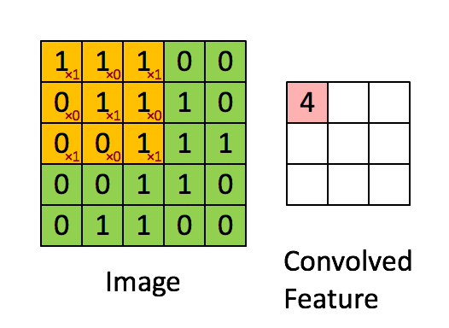

* **How it works**:
  + Kernels slide over the image, performing element-wise multiplications and summing the results (convolution operation).
  + The result is a **feature map** that highlights specific patterns.
* **Importance**: Learns spatial features, preserving the relationship between pixels.
* **Example**: Detects edges or corners in an image of a face.

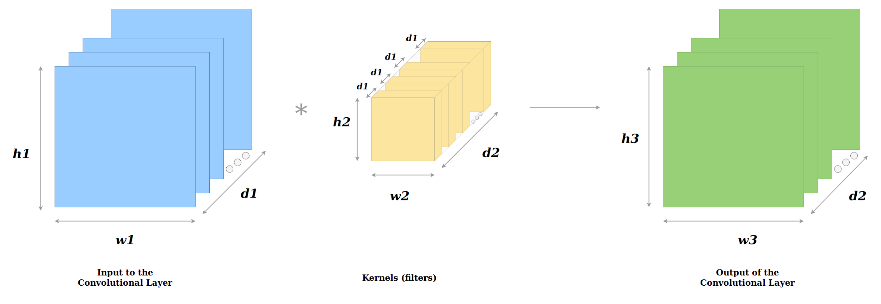



Here in above figure stride is 2,filter convolve over image with 2 difference in horizontal and vertical slide.

### **3. Activation Layer (ReLU)**

* **Purpose**: Introduces non-linearity by converting negative values in the feature map to zero.
* **Importance**:
  + Helps the CNN learn complex patterns.
  + Without this layer, the CNN would behave like a linear model, limiting its capability.

### **4. Pooling Layer**

* **Purpose**: Reduces the spatial size of the feature maps while retaining important information.

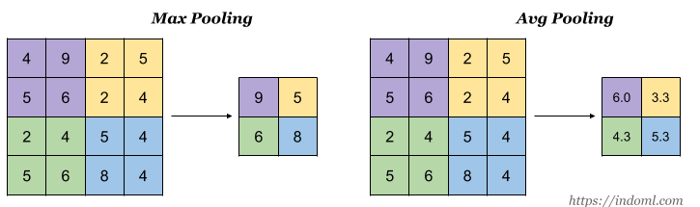

* **Types**:
  + **Max Pooling**: Keeps the maximum value in a region.
  + **Average Pooling**: Computes the average value in a region.
* **Importance**:
  + Reduces computational cost.
  + Prevents overfitting by generalizing feature detection.
  + Makes the network invariant to small translations (e.g., shifting an object slightly in an image).
  + Pooling downsamples the image in its height and width but the number of channels(depth) stays the same.

### **5. Flattening Layer**

* **Purpose**: Converts the 2D or 3D feature maps into a 1D vector.

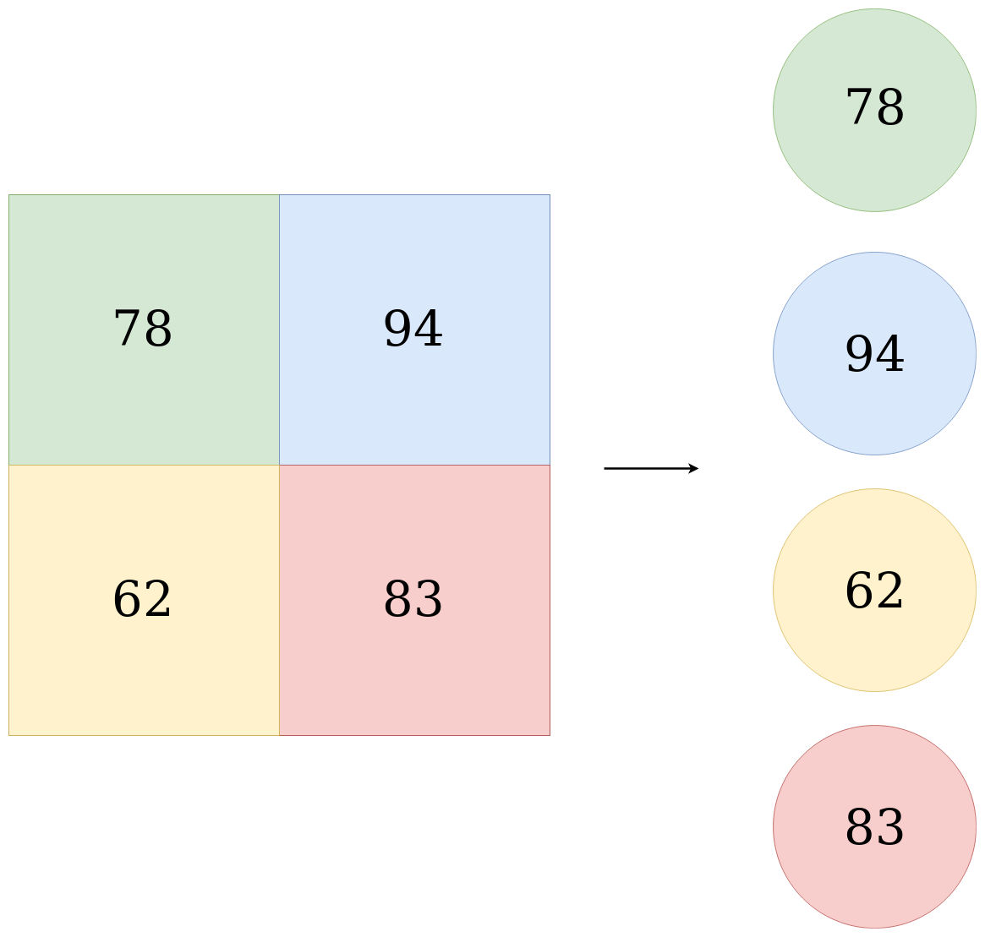

* **Importance**: Prepares the data for the fully connected layer.

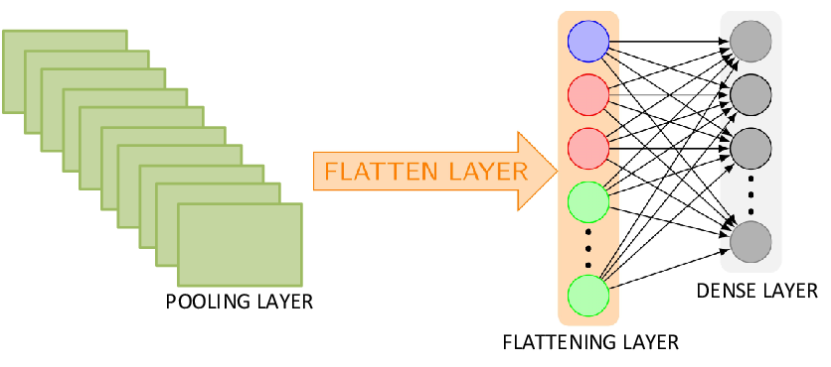

### **6. Fully Connected Layer (Dense Layer)**

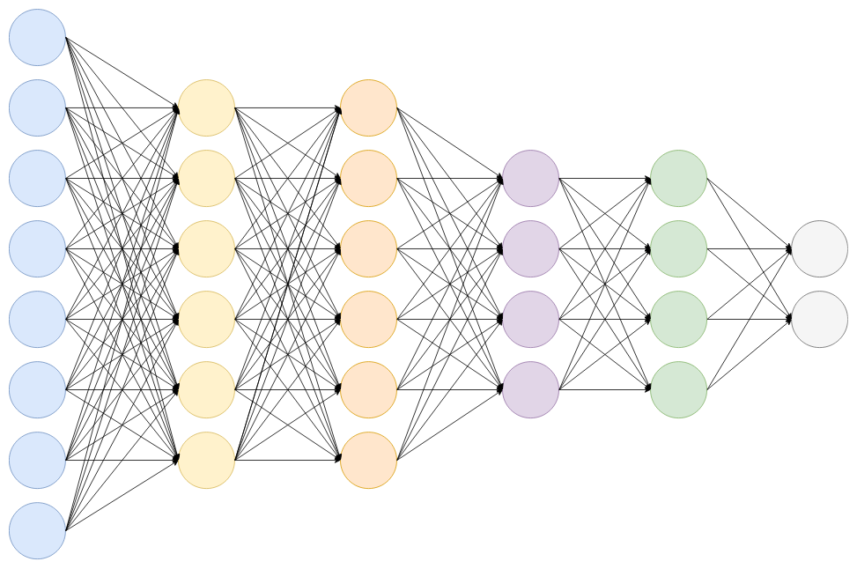

* **Purpose**: Acts as the decision-making part of the network.
  + Every neuron is connected to every feature from the previous layer.
* **Importance**:
  + Combines extracted features to make predictions.
  + Example: Uses detected edges, shapes, and textures to classify an image as a cat or dog.

### **7. Dropout Layer**

* **Purpose**: Randomly ignores (drops) a percentage of neurons during training.
* **Importance**:
  + Prevents overfitting.
  + Improves generalization to unseen data.

### **8. Output Layer (Softmax/Logits)**

* **Purpose**: Provides the final prediction.
  + **Softmax**: Converts raw scores (logits) into probabilities (used for multi-class classification).
  + **Sigmoid**: Outputs a single probability for binary classification tasks.

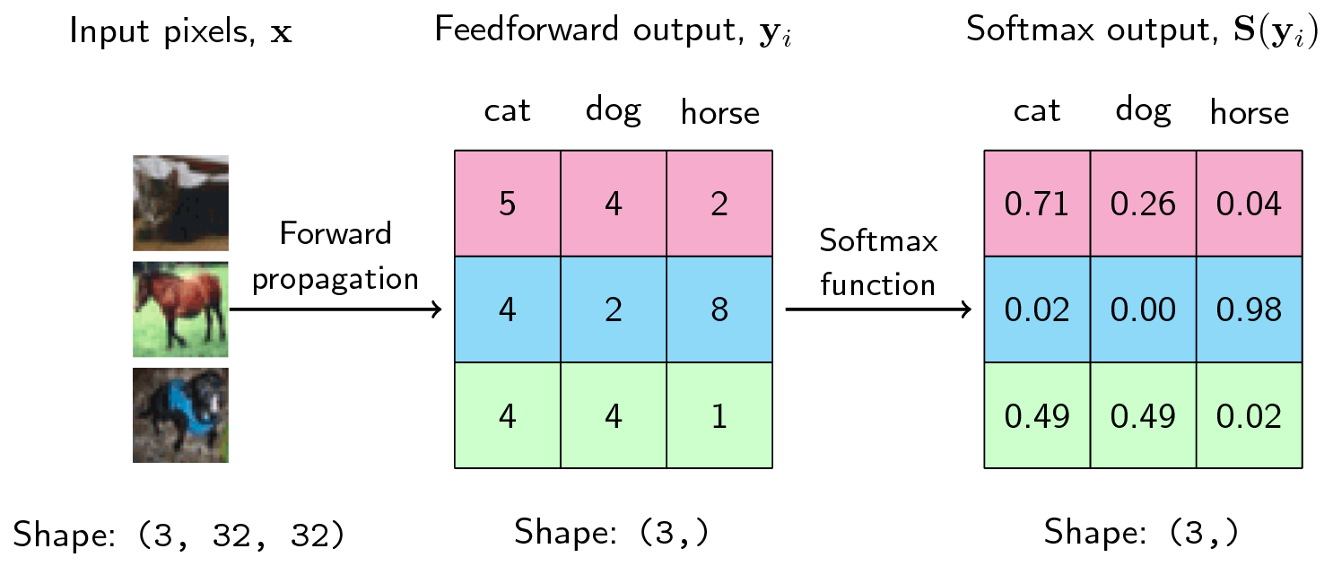

* **Importance**: Ensures outputs are interpretable as probabilities.

### **How the Layers Work Together**

1. **Early Layers**: Detect simple patterns (e.g., edges, lines).
2. **Middle Layers**: Combine simple patterns into complex features (e.g., eyes, ears).
3. **Final Layers**: Combine these features to identify the object (e.g., "This is a cat").

For each layer of the Artificial Neural Network, the following calculation takes place(falls in DENSE Layers)

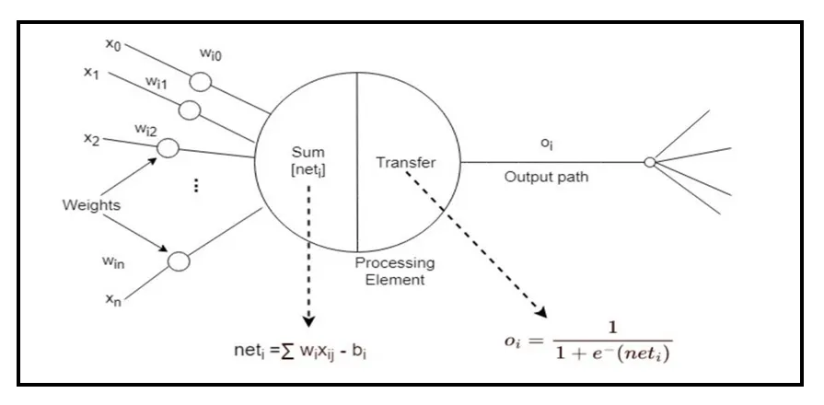



ANN Calculation for each layer

where,  
**x** — *is the input vector with dimension* ***[p_l, 1]*W** — *Is the weight matrix with dimensions* ***[p_l, n_l]*** *where,* ***p_l*** *is the number of neurons in the previous layer and* ***n_l*** *is the number of neurons in the current layer.***b** *— Is the bias vector with dimension* ***[p_l, 1]*g** *— Is the activation function, which is usually* ***ReLU****.*

This calculation is repeated for each layer.

After passing through the fully connected layers, the final layer uses the ***softmax activation function*** *(instead of ReLU)* which is used to get probabilities of the input being in a particular class (*classification*).

**Summary:**

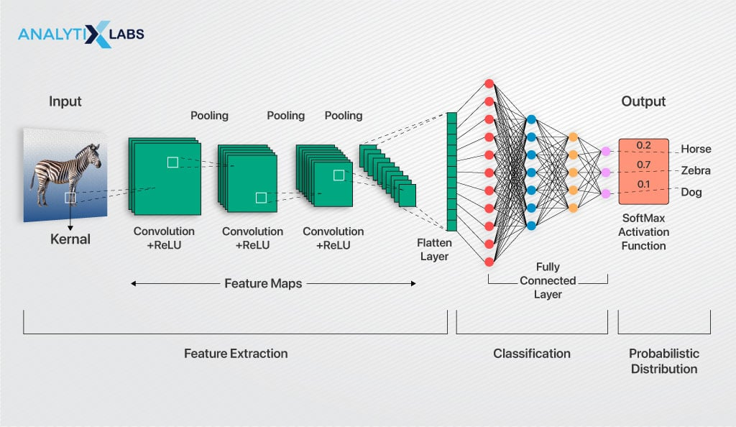

**7.2 Image Classification**

[**https://www.analyticsvidhya.com/blog/2020/02/learn-image-classification-cnn-convolutional-neural-networks-3-datasets/**](https://www.analyticsvidhya.com/blog/2020/02/learn-image-classification-cnn-convolutional-neural-networks-3-datasets/)

#### **What is Image Classification?**

* Assigns a label or tag to an entire image based on training data of labeled images.
* Involves pixel-level analysis to determine the most suitable label.
* Enables valuable insights and informed decisions.

#### **Data Labeling in Training**

* Accurate labeling during the training phase is crucial to avoid discrepancies.
* Often employs publicly available datasets for reliable model training.

#### **Types of Image Classification**

1. **Binary Classification**
   * Labels images into two categories (e.g., benign/malignant tumors, defect/no defect).
   * Answers yes/no questions.
2. **Multiclass Classification**
   * Categorizes items into three or more classes (e.g., sentiment analysis, disease classification).
3. **Multilabel Classification**
   * Allows an image to have multiple labels (e.g., identifying all colors in a fruit salad image).
4. **Hierarchical Classification**
   * Organizes classes into a hierarchical structure with broad and specific categories.
   * Example: Identifying fruit type (apple vs. grape) followed by subtypes (Honeycrisp, Red Delicious).

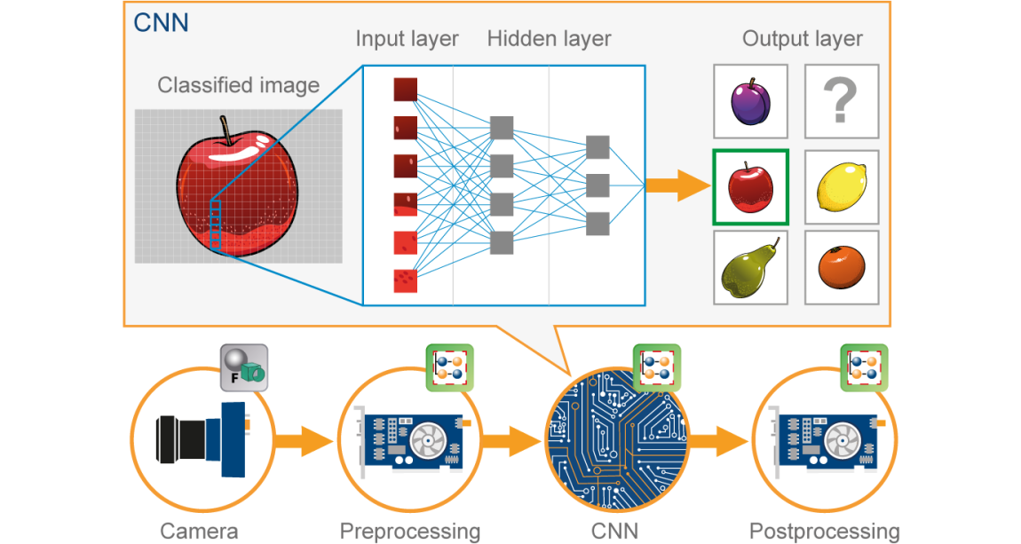

#### **Image Classification vs. Object Detection**

* **Image Classification**: Assigns one label to the entire image.
* **Object Localization**: Identifies and locates specific objects in an image (uses bounding boxes).
* **Object Detection**: Combines classification and localization to identify multiple objects and their positions.

#### **How Image Classification Works**

1. **Image Pre-processing**
   * Improves image quality for analysis.
   * Techniques: resizing, cropping, normalization, noise reduction, data augmentation.
2. **Feature Extraction**
   * Identifies visual patterns (e.g., edge detection, texture analysis, CNN-based feature learning).
   * Essential for distinguishing between classes.
3. **Object Classification**
   * Uses machine learning algorithms to assign the image to a class based on extracted features.

#### **Deep Neural Networks in Image Classification**

* **Convolutional Neural Networks (CNNs)**
  + Key layers: input layer, convolution layer, pooling layer, ReLU layer.
  + Extracts features directly from raw data.
  + Achieves state-of-the-art performance in image classification tasks

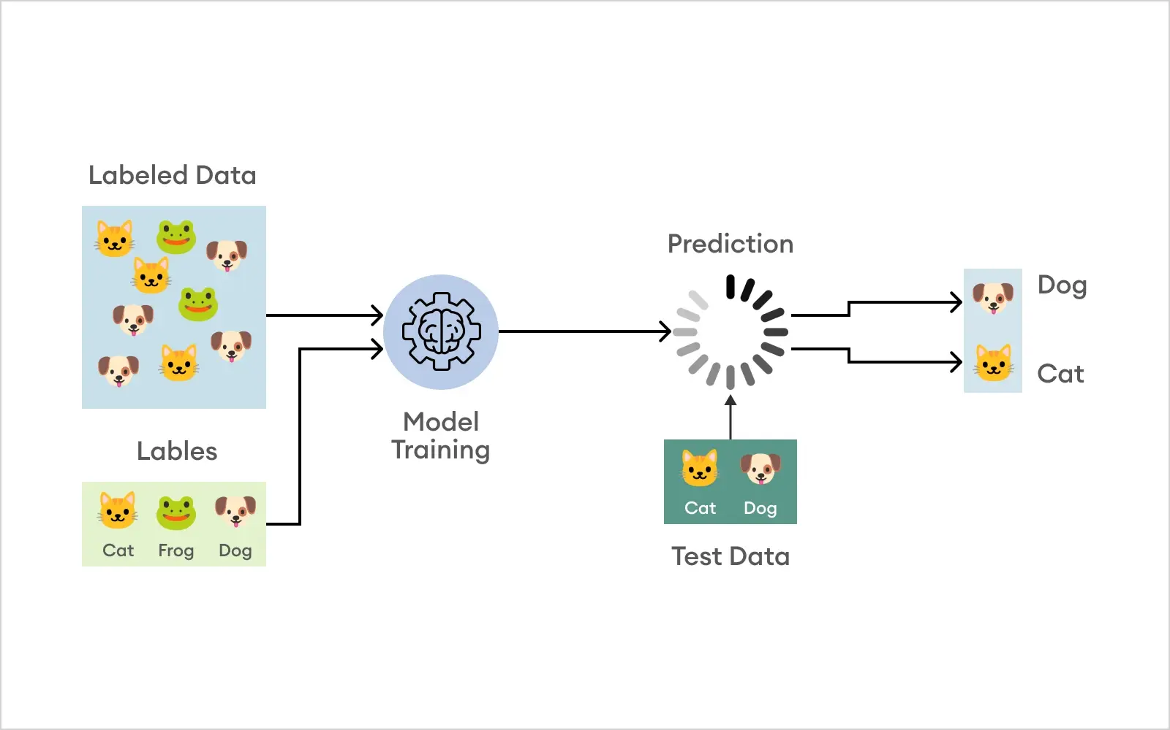

**CLASSIFICATION FOR READY DATA:**

Here’s a **step-by-step guide** to build an image classification model using **TensorFlow** and **Keras**:

### **Step 1: Install Required Libraries**

pip install tensorflow matplotlib

### **Step 2: Import Necessary Libraries**

import tensorflow as tf

from tensorflow.keras.models import Sequential

from tensorflow.keras.layers import Conv2D, MaxPooling2D, Flatten, Dense, Dropout

from tensorflow.keras.preprocessing.image import ImageDataGenerator

import matplotlib.pyplot as plt

### **Step 3: Load and Preprocess Data**

* Use a dataset like CIFAR-10, MNIST, or load your custom dataset.
* Normalize pixel values to range [0,1].

#### **Example with CIFAR-10:**

# Load CIFAR-10 dataset

(x_train, y_train), (x_test, y_test) = tf.keras.datasets.cifar10.load_data()

# Normalize pixel values

x_train, x_test = x_train / 255.0, x_test / 255.0

# Convert labels to one-hot encoding

y_train = tf.keras.utils.to_categorical(y_train, 10)

y_test = tf.keras.utils.to_categorical(y_test, 10)

### **Step 4: Define the CNN Model**

model = Sequential([

# Convolutional layers

Conv2D(32, (3, 3), activation='relu', input_shape=(32, 32, 3)),

MaxPooling2D((2, 2)),

Conv2D(64, (3, 3), activation='relu'),

MaxPooling2D((2, 2)),

# Flatten and Dense layers

Flatten(),

Dense(128, activation='relu'),

Dropout(0.5),

Dense(10, activation='softmax') # 10 classes for CIFAR-10

])

### **Step 5: Compile the Model**

* Choose an optimizer, loss function, and evaluation metrics.

model.compile(optimizer='adam',

loss='categorical_crossentropy',

metrics=['accuracy'])

### **Step 6: Augment Data (Optional)**

* Use **ImageDataGenerator** for real-time data augmentation.

datagen = ImageDataGenerator(

rotation_range=15,

width_shift_range=0.1,

height_shift_range=0.1,

horizontal_flip=True)

datagen.fit(x_train)

### **Step 7: Train the Model**

* Train the model using the training data.

history = model.fit(datagen.flow(x_train, y_train, batch_size=64),

epochs=10,

validation_data=(x_test, y_test))

### **Step 8: Evaluate the Model**

* Check the model’s performance on the test dataset.

test_loss, test_accuracy = model.evaluate(x_test, y_test)

print(f"Test Accuracy: {test_accuracy:.2f}")

### **Step 9: Visualize Training Results**

* Plot training and validation accuracy/loss.

plt.plot(history.history['accuracy'], label='Training Accuracy')

plt.plot(history.history['val_accuracy'], label='Validation Accuracy')

plt.xlabel('Epochs')

plt.ylabel('Accuracy')

plt.legend()

plt.show()

### **Step 10: Save and Load the Model**

* Save the trained model for future use.

model.save('image_classification_model.h5')

* Load the model later.

loaded_model =tf.keras.models.load_model('image_classification_model.h5')

### **Step 11: Make Predictions**

* Use the model to classify new images.

import numpy as np

# Load an image and preprocess

new_image = x_test[0] # Example: using a test image

new_image = np.expand_dims(new_image, axis=0) # Add batch dimension

# Predict

predictions = model.predict(new_image)

print("Predicted Class: {np.argmax(predictions)}")

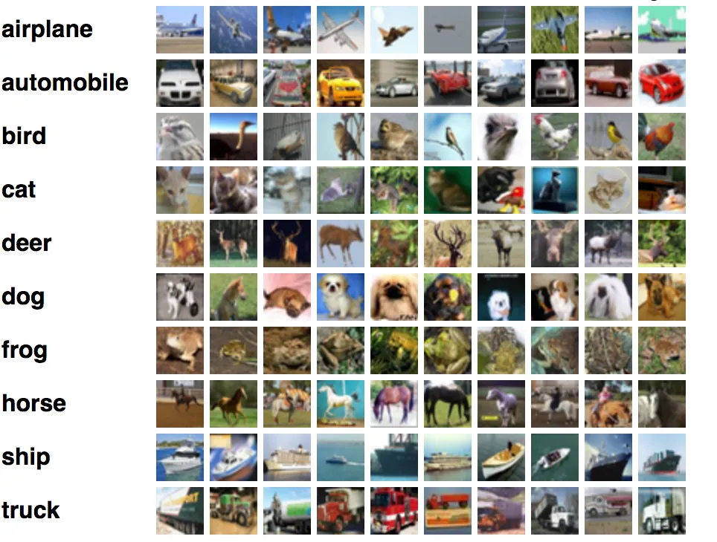

| **Function** | **Purpose** | **Parameters** | **Example** |
| --- | --- | --- | --- |
| tf.keras.datasets.<dataset>.load_data() | Loads pre-defined datasets like CIFAR-10, MNIST, etc. | - None | (x_train, y_train), (x_test, y_test) = tf.keras.datasets.cifar10.load_data() |
| Sequential() | Creates a sequential model by stacking layers linearly. | - None | model = Sequential([...]) |
| Conv2D(filters, kernel_size, activation, input_shape) | Adds a convolutional layer to extract features from input data. | filters: Number of filters (kernels).  kernel_size: Size of the kernel (e.g., (3, 3)).  activation: Activation function (e.g., 'relu').  input_shape: Shape of input (only for the first layer). | Conv2D(32, (3, 3), activation='relu', input_shape=(32, 32, 3)) |
| MaxPooling2D(pool_size) | Reduces spatial dimensions using pooling. | pool_size: Size of the pooling window (e.g., (2, 2)). | MaxPooling2D((2, 2)) |
| Flatten() | Flattens 2D/3D feature maps into a 1D vector. | - None | Flatten() |
| Dense(units, activation) | Fully connected layer for predictions or feature combination. | units: Number of neurons.  activation: Activation function (e.g., 'relu', 'softmax'). | Dense(128, activation='relu') |
| Dropout(rate) | Drops a fraction of neurons randomly during training. | rate: Fraction of neurons to drop (e.g., 0.5). | Dropout(0.5) |
| model.compile(optimizer, loss, metrics) | Configures the model for training. | optimizer: Optimization algorithm (e.g., 'adam').  loss: Loss function (e.g., 'categorical_crossentropy').  metrics: Metrics for evaluation (e.g., 'accuracy'). | model.compile(optimizer='adam', loss='categorical_crossentropy', metrics=['accuracy']) |
| ImageDataGenerator() | Applies real-time data augmentation for training. | rotation_range: Degree of rotation.  width_shift_range: Fraction for horizontal shift.  height_shift_range: Fraction for vertical shift.  horizontal_flip: Boolean for flipping horizontally. | ImageDataGenerator(rotation_range=15, width_shift_range=0.1, horizontal_flip=True) |
| model.fit(x, y, batch_size, epochs, validation_data) | Trains the model on the training data. | x, y: Training data and labels.  batch_size: Number of samples per batch.  epochs: Number of training cycles.  validation_data: Data for validation during training. | model.fit(datagen.flow(x_train, y_train, batch_size=64), epochs=10, validation_data=(x_test, y_test)) |
| model.evaluate(x, y) | Evaluates the model’s performance on test data. | x, y: Test data and labels. | test_loss, test_accuracy = model.evaluate(x_test, y_test) |
| model.save(filepath) | Saves the trained model to a file. | filepath: Path to save the model. | model.save('model.h5') |
| model.predict(x) | Makes predictions on new/unseen data. | x: Input data for predictions. | predictions = model.predict(new_image) |

**CLASSIFICATION FOR SELF DATA:**

**step-by-step guide to building an image classification model from scratch** using your

own dataset:

### **Step 1: Prepare Your Dataset**

Organize your images in a folder structure:  
dataset/

train/

class1/

img1.jpg

img2.jpg

class2/

img3.jpg

img4.jpg

validation/

class1/

img5.jpg

class2/

img6.jpg

1. Data :
   * train/ is for training images.
   * validation/ is for validation images.
2. Ensure that the dataset has balanced classes for better performance.

### **Upload Your Dataset to Google Colab**

1. **Compress your dataset** (organized in train/validation folders) into a .zip file.
2. Upload it to your Colab environment:

Run the following code to upload files interactively:  
  
from google.colab import files

uploaded = files.upload()

After uploading, unzip the dataset:  
 import zipfile

import os

zip_path = '/content/your_dataset.zip' # Replace with your uploaded file name

with zipfile.ZipFile(zip_path, 'r') as zip_ref:

zip_ref.extractall('/content/dataset')

dataset_path = '/content/dataset'

### **Step 2: Import Required Libraries**

import tensorflow as tf

from tensorflow.keras.models import Sequential

from tensorflow.keras.layers import Conv2D, MaxPooling2D, Flatten, Dense, Dropout

from tensorflow.keras.preprocessing.image import ImageDataGenerator

import matplotlib.pyplot as plt

### **Step 3: Set Dataset Paths**

train_dir = '/content/dataset/train'

validation_dir = '/content/dataset/validation'

### **Step 4: Data Preprocessing**

Prepare the data generators for training and validation.

# Data augmentation for training

train_datagen = ImageDataGenerator(

rescale=1.0/255,

rotation_range=20,

width_shift_range=0.2,

height_shift_range=0.2,

shear_range=0.2,

zoom_range=0.2,

horizontal_flip=True,

fill_mode='nearest'

)

# Rescale validation data

validation_datagen = ImageDataGenerator(rescale=1.0/255)

# Create generators

train_generator = train_datagen.flow_from_directory(

train_dir,

target_size=(150, 150),

batch_size=32,

class_mode='categorical' # Use 'binary' for binary classification

)

validation_generator = validation_datagen.flow_from_directory(

validation_dir,

target_size=(150, 150),

batch_size=32,

class_mode='categorical'

)

### **Step 5: Define the CNN Model**

Create a sequential CNN architecture.

model = Sequential([

Conv2D(32, (3, 3), activation='relu', input_shape=(150, 150, 3)),

MaxPooling2D((2, 2)),

Conv2D(64, (3, 3), activation='relu'),

MaxPooling2D((2, 2)),

Conv2D(128, (3, 3), activation='relu'),

MaxPooling2D((2, 2)),

Flatten(),

Dense(512, activation='relu'),

Dropout(0.5),

Dense(train_generator.num_classes, activation='softmax')

])

### **Step 6: Compile the Model**

model.compile(

optimizer='adam',

loss='categorical_crossentropy',

metrics=['accuracy']

)

### **Step 7: Train the Model**

Fit the model using the data generators.

history = model.fit(

train_generator,

steps_per_epoch=train_generator.samples // train_generator.batch_size,

epochs=10,

validation_data=validation_generator,

validation_steps=validation_generator.samples // validation_generator.batch_size

)

### **Step 8: Visualize Training Results**

Plot the training and validation accuracy/loss.

# Plot accuracy

plt.plot(history.history['accuracy'], label='Training Accuracy')

plt.plot(history.history['val_accuracy'], label='Validation Accuracy')

plt.xlabel('Epochs')

plt.ylabel('Accuracy')

plt.legend()

plt.show()

# Plot loss

plt.plot(history.history['loss'], label='Training Loss')

plt.plot(history.history['val_loss'], label='Validation Loss')

plt.xlabel('Epochs')

plt.ylabel('Loss')

plt.legend()

plt.show()

### **Step 9: Save the Model**

Save the trained model in Google Drive.

from google.colab import drive

drive.mount('/content/drive')

model.save('/content/drive/MyDrive/custom_image_classifier.h5')

### **Step 10: Test the Model**

Test the model on new images uploaded to Colab.

**Upload a new image**:

from google.colab import files

uploaded = files.upload()

**Load and preprocess the image**:  
from tensorflow.keras.preprocessing import image

import numpy as np

img_path = 'uploaded_image.jpg' # Replace with the uploaded file name

img = image.load_img(img_path, target_size=(150, 150))

img_array = image.img_to_array(img) / 255.0 # Normalize

img_array = np.expand_dims(img_array, axis=0) # Add batch dimension

**Predict the class**:  
predictions = model.predict(img_array)

predicted_class = np.argmax(predictions)

print(f"Predicted Class: {predicted_class}")

**7.3 Object Detection**

A computer vision process of identifying examples of various objects in videos or images. Deep learning or machine learning are usually leveraged by object detection algorithms to create significant results. Humans locate objects and recognize images or videos in a matter of seconds but objection detection replicates this intelligence by using a computer.

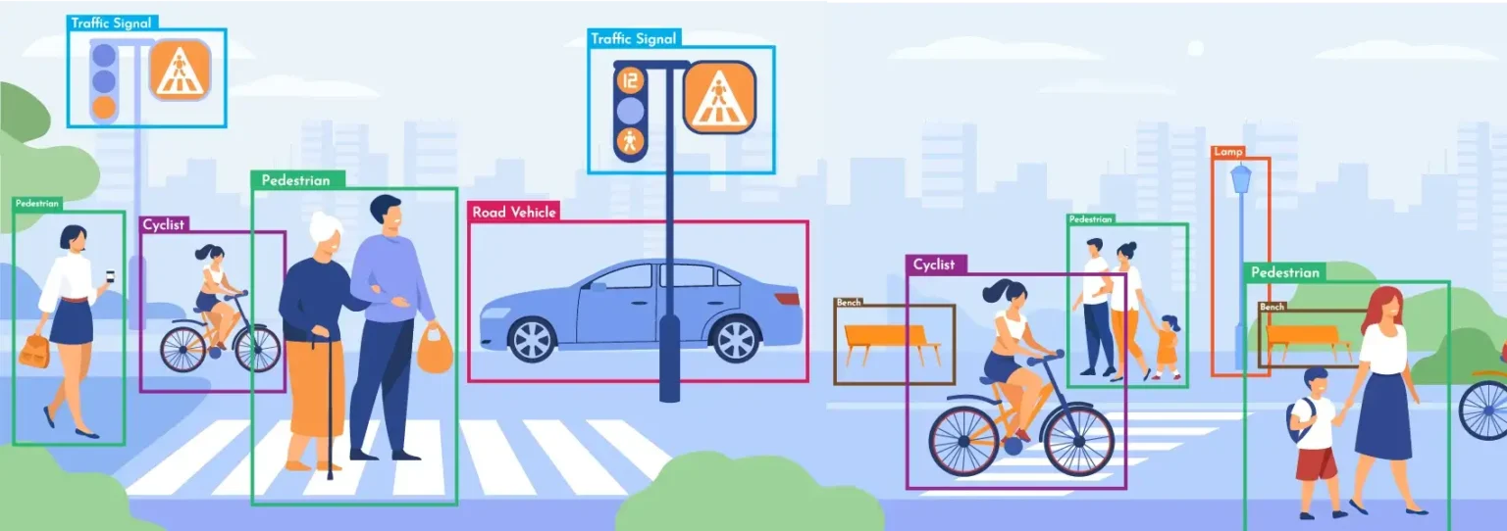

**7.3.1 YOLO**

<https://medium.com/@shroffmegha6695/object-detection-with-deep-learning-beginners-friendly-key-terms-explanation-d4fb594fea83>

1. **YOLO's Purpose:** Real-time object detection combining classification and bounding box prediction in a single neural network.
2. **Advantages**:
   * Faster performance: Detects objects at 45 FPS.
   * Captures the entire image context in one look.
   * Generalizes well across different environments.

#### **YOLO Architecture:**

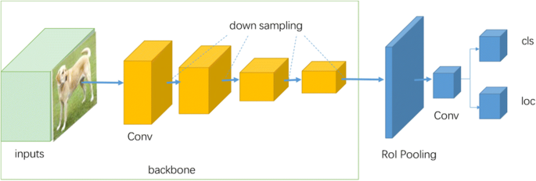

1. **Components**:
   * **Backbone**: Convolutional layers for feature extraction.
   * **Neck**: Fully connected layers for probabilities and bounding box coordinates.
   * **Head**: Outputs predictions as a tensor.
2. **Training Details**:
   * Pre-trained backbone on ImageNet; uses additional layers for detection.
   * Higher resolution (448x448) for finer detection.
   * Loss Function: Adjusts weights for localization and classification errors using coefficients λcoord​ and λnoobj

YOLO (You Only Look Once) performs object detection explained step-by-step in a simplified way, using the example of detecting players and soccer balls:

### **1. Residual Blocks**

* The image is divided into a grid of **NxN cells** (e.g., 4x4 in this case).
* Each cell predicts:
  + If it contains an object.
  + The class of the object (e.g., "Player" or "Ball").
  + A confidence score for the prediction.
* **Key Idea:** Each grid cell "looks" only at the portion of the image it covers to localize objects.

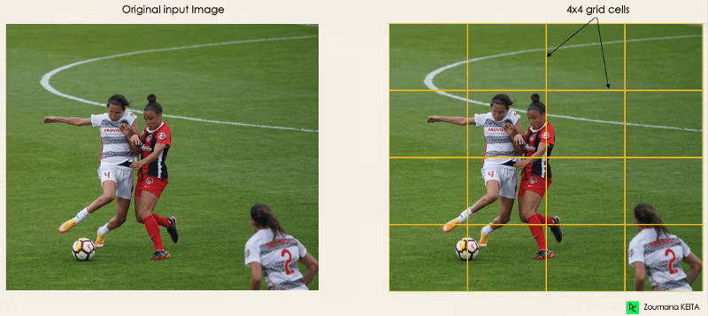

### **2. Bounding Box Regression**

* YOLO predicts a bounding box for each object.
* A bounding box is represented by a vector Y=[pc,bx,by,bh,bw,c1,c2]
  + pc​: Probability the grid contains an object (higher for grids covering actual objects).
  + bx,by​: Coordinates of the box's center relative to the grid cell.
  + bh,bw​: Height and width of the bounding box.
  + c1,c2​: Class scores (e.g., "Player" or "Ball").
* This helps identify the position and size of objects, as seen with the bounding box around the player.

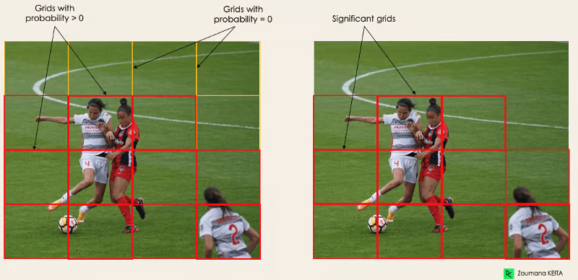

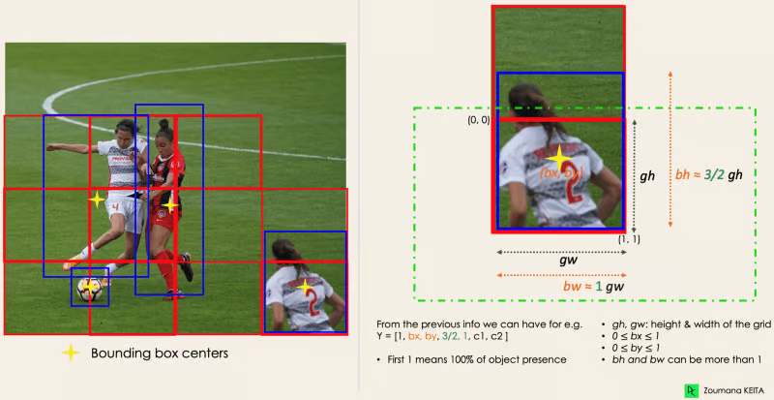

### **3. Intersection Over Union (IOU)**

* Multiple grid cells may predict bounding boxes for the same object.
* To avoid duplicates, YOLO calculates **IOU**, the overlap ratio between predicted and actual boxes:
* Predictions with IOU below a **threshold** (e.g., 0.5) are discarded, retaining only relevant boxes.

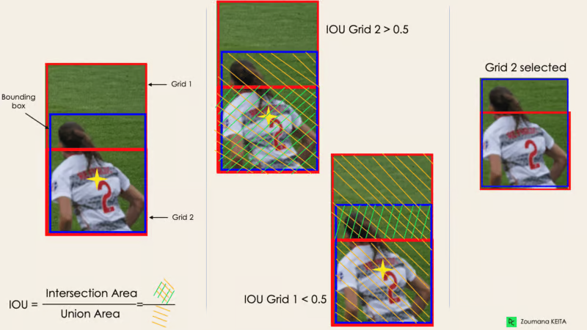

### **4. Non-Maximum Suppression (NMS)**

* Even after IOU filtering, multiple bounding boxes may remain for a single object.
* **NMS** helps by:
  1. Selecting the box with the highest confidence score.
  2. Discarding overlapping boxes with lower confidence.
* The final result is a clean detection of objects with minimal noise.

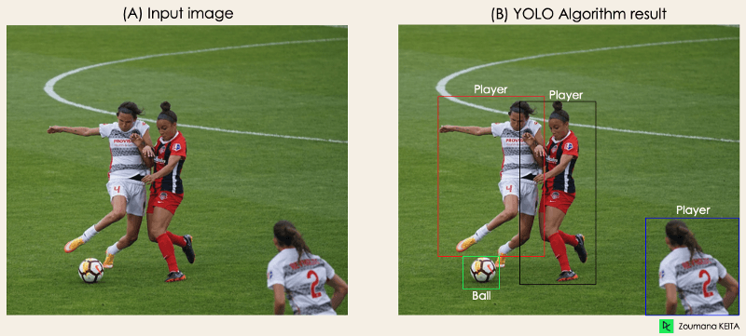

### **Summary of Process**

1. The image is split into a grid.
2. Each grid predicts objects and bounding boxes.
3. IOU filters out irrelevant predictions.
4. NMS ensures only the best bounding boxes remain.
5. 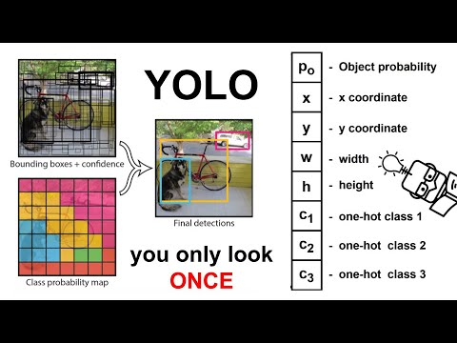

This efficient pipeline enables YOLO to detect multiple objects in real time, as shown by the transformation from Image (A) to Image (B). It explains how YOLO can detect both players and soccer balls accurately while ignoring background noise.

#### **Limitations:**

1. Struggles with:
   * Detecting multiple objects in a single grid cell.
   * Groups of small objects or different classes in close proximity.
2. Restricted to a limited number of bounding boxes and class predictions per cell.

| **Step 1: Upload Kaggle API Key**  1. Download your Kaggle API key (kaggle.json) from your Kaggle account:    * Go to Account Settings.    * Click "Create New API Token" to download the kaggle.json file. 2. Upload the kaggle.json file in Colab:    * Run the cell below in Colab and click on the "Choose Files" button to upload the file.   from google.colab import files  files.upload() **Step 2: Set Up the Environment** !pip install ultralytics **Step 3: YOLOv5 Object Detection Code** Here’s the main code for performing object detection on an image from the Kaggle dataset:  from ultralytics import YOLO  import cv2  import matplotlib.pyplot as plt  import os  # Load the YOLOv5 model  model = YOLO('yolov5s') # Use the small YOLOv5 model  # Path to the image  image_path = '/content/dataset/training_set/cats/cat.1.jpg' # Replace with the actual path to an image in the dataset  # Check if the image exists  if not os.path.exists(image_path):  print("Image not found at {image_path}")  else:  # Load and preprocess the image  image = cv2.imread(image_path)  image_rgb = cv2.cvtColor(image, cv2.COLOR_BGR2RGB)  # Perform object detection  results = model.predict(source=image_rgb, conf=0.5) # Confidence threshold set to 0.5  # Visualize the results  plt.figure(figsize=(10, 10))  plt.imshow(cv2.cvtColor(results[0].plot(), cv2.COLOR_BGR2RGB))  plt.axis('off')  plt.show() |
| --- |

## 

## **THE SINGLE SHOT DETECTOR (SSD)**

<https://jonathan-hui.medium.com/ssd-object-detection-single-shot-multibox-detector-for-real-time-processing-9bd8deac0e06>

## **Key Features of SSD**

* Single Shot:It directly predicts the presence of objects and their bounding box coordinates in a single shot, making it faster and more efficient.
* MultiBox: SSD uses a set of default bounding boxes (anchor boxes) of different scales and aspect ratios at multiple locations in the input image. SSD predicts adjustments to these default boxes to locate objects accurately.
* Multi-Scale Detection: SSD operates on multiple feature maps with different resolutions. Predictions are made at different scales to capture objects at varying levels of granularity.

**The architecture consists of two main components:**

* Backbone Network: The backbone network comprises convolutional layers without the fully connected classification layers. It extracts rich features from the input image.
* Custom Convolutional Layers:
  1. Multi-Scale Feature Maps for Detection: After the backbone network, a series of convolutional layers are stacked on top. These custom layers progressively decrease in size and enable predictions at multiple scales.
  2. Convolutional Predictors for Detection: For each added layer, a 3x3 kernel is applied in a convolutional manner to produce class probabilities and adjustments to default boxes. they are placed in each feature map cell.

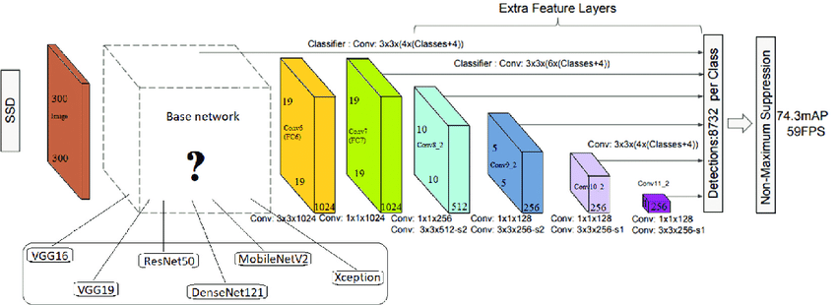

### **Step-by-Step Explanation of SSD (Single Shot MultiBox Detector)**

## SSD is an object detection algorithm that detects objects in images and provides their classes and bounding boxes. Below is a step-by-step explanation of how SSD works, along with an example for implementation.

### **1. Input Image Preprocessing**

#### **Explanation:**

## Resize the input image to a fixed size (e.g., 300x300 or 320x320, depending on the SSD model).

## Normalize pixel values (if required) and convert the image into a tensor with a batch dimension.

### **2. Feature Extraction**

#### **Explanation:**

## SSD uses a backbone network (e.g., VGG16, MobileNet, or ResNet) to extract feature maps from the input image.

## These feature maps capture spatial and semantic information for object detection.

#### **Behind the Scenes:**

## The backbone extracts features at multiple scales to detect objects of various sizes.

### **3. Anchor Boxes:::::IMP**

### **Detailed Explanation of Anchor Boxes in SSD (Single Shot MultiBox Detector)**

#### **What Are Anchor Boxes?**

## **Anchor Boxes**: Predefined boxes that serve as references for the object detection process.

## These boxes are used to propose potential locations for objects in the image.

## They come in different shapes and sizes to cover a variety of object shapes and scales.

#### **Role of Anchor Boxes in SSD**

## SSD uses anchor boxes as initial estimates for the location and size of the object.

## The network adjusts these anchor boxes to better fit the detected objects in the image.

### **How Anchor Boxes Work in SSD**

## **Anchor Box Placement**:

## Anchor boxes are defined at each location (cell) in the feature map grid.

## These predefined boxes are placed at different aspect ratios and scales to match objects of various shapes.

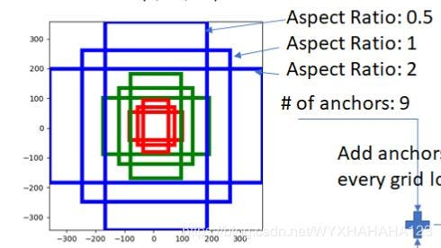

## **Adjustment of Anchor Boxes**:

## The SSD network predicts how much each anchor box should be modified:

## **Translation**: Shifting the box position.

## **Scaling**: Changing the size of the box.

## The network adjusts the anchor boxes by computing offsets that modify their position and size to best fit the object in the image.

## **Multiple Anchor Boxes per Cell**:

## Each grid cell in the feature map can have **multiple anchor boxes** associated with it.

## These anchor boxes can have different aspect ratios and sizes.

## For example, a cell could have 4 or more anchor boxes (depending on the configuration).

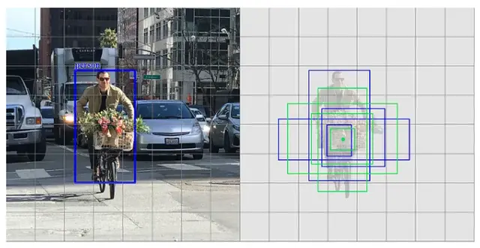

### **Anchor Boxes in SSD Layers**

## **Different Layers, Different Anchor Box Sizes**:

## Anchor boxes in SSD are tied to different feature map layers with varying resolutions:

## **High-resolution layers**: Detect smaller objects (fine-grained boxes).

## **Low-resolution layers**: Detect larger objects (coarse-grained boxes).

## As the feature map resolution decreases through successive convolutional layers, anchor boxes are able to detect larger objects.

### **Adjusting the Anchor Boxes**

## **Anchor Box Predictions**:

## The network predicts the **offsets** for the anchor boxes:

## **Center coordinates** (x, y).

## **Width and height** of the bounding box.

## The predicted box is compared with the ground truth box to calculate the loss (based on **Jaccard Index** or **IOU**).

## **Confidence Scores**: Each anchor box is also assigned a confidence score indicating the likelihood of an object being present within that box.

## **Matching Anchor Boxes**:

## During training, anchor boxes are matched with ground truth boxes based on the **Intersection over Union (IOU)** threshold:

## **IOU ≥ 0.5**: The anchor box is considered a match.

## **IOU < 0.5**: The anchor box is ignored.

## This helps the model learn which anchor boxes should be adjusted for each object.

### 

### **Example of Anchor Boxes in SSD**

## **Default Anchors**:

## SSD uses a set of predefined aspect ratios and scales for anchor boxes.

## Typically, anchor boxes include:

## Square boxes (aspect ratio 1:1).

## Long boxes (aspect ratios like 2:1, 1:2).

## These anchor boxes help the network detect objects of varying shapes and sizes.

## **Anchor Box Variations**:

## The network may generate predictions based on multiple anchor boxes per cell.

## For instance, each feature map location may have 4 or more anchor boxes with different aspect ratios:

## **4 Anchor Boxes per Grid Cell**: For example, aspect ratios such as 1:1, 2:1, 1:2, and 1:3.

## After adjusting the anchor boxes, SSD predicts both the **bounding box** (location, width, height) and the **object class** for each anchor box.

### **4. Predictions for Each Anchor Box:**

## For each anchor box, SSD predicts:

## **Class Scores**: The probability of each class for the object in the box.

## **Bounding Box Offsets**: Adjustments to the default anchor box to better fit the detected object.

### **5. Non-Maximum Suppression (NMS):**

## Post-processing is applied to filter out overlapping and low-confidence detections.

## NMS ensures that only the best bounding box for each detected object remains.

### **6. Output**

## SSD outputs a set of bounding boxes, their associated class labels, and confidence scores.

## import cv2

## import numpy as np

## import tensorflow as tf

## 

## # Load TensorFlow SSD model

## model_path = tf.keras.utils.get_file(

## 'ssd_mobilenet_v2_fpnlite_320x320',

## 'http://download.tensorflow.org/models/object_detection/ssd_mobilenet_v2_fpnlite_320x320_coco17_tpu-8.tar.gz',

## untar=True

## )

## saved_model_dir = f"{model_path}/saved_model"

## detect_fn = tf.saved_model.load(saved_model_dir)

## 

## # Load and preprocess the image

## image_path = "input_image.jpg"

## image = cv2.imread(image_path)

## height, width, _ = image.shape

## 

## # Resize image for SSD input

## input_tensor = cv2.resize(image, (320, 320))

## input_tensor = np.expand_dims(input_tensor, axis=0)

## input_tensor = tf.convert_to_tensor(input_tensor, dtype=tf.uint8)

## 

## # Perform inference

## detections = detect_fn(input_tensor)

## 

## # Extract detection results

## boxes = detections['detection_boxes'][0].numpy()

## classes = detections['detection_classes'][0].numpy().astype(np.int32)

## scores = detections['detection_scores'][0].numpy()

## 

## # Draw detections on the image

## for i in range(len(scores)):

## if scores[i] > 0.5: # Confidence threshold

## box = boxes[i]

## y1, x1, y2, x2 = box

## x1, x2 = int(x1 * width), int(x2 * width)

## y1, y2 = int(y1 * height), int(y2 * height)

## 

## # Draw bounding box and label

## cv2.rectangle(image, (x1, y1), (x2, y2), (0, 255, 0), 2)

## label = f"Class {classes[i]}: {scores[i]:.2f}"

## cv2.putText(image, label, (x1, y1 - 10), cv2.FONT_HERSHEY_SIMPLEX, 0.5, (255, 0, 0), 2)

## 

## # Display the image with detections

## cv2.imshow("Detections", image)

## cv2.waitKey(0)

## cv2.destroyAllWindows()

## —----------------------------------------finish chp—----------------------------------------------

**Self Practice:**

Here is the complete code to build a male-female classification CNN model on **Google Colab**. Follow these steps:

### **Step 1: Set Up Google Colab**

1. Open Google Colab.
2. Create a new notebook and follow these steps.

### **Step 2: Import Libraries**

import tensorflow as tf

from tensorflow.keras.models import Sequential

from tensorflow.keras.layers import Conv2D, MaxPooling2D, Flatten, Dense, Dropout

from tensorflow.keras.preprocessing.image import ImageDataGenerator

import zipfile

import os

### **Step 3: Upload Dataset**

1. Organize your dataset:
   * train/male/ for male images.
   * train/female/ for female images.
   * test/male/ and test/female/ for testing images.
2. Compress your dataset into a .zip file and upload it to Colab.
3. Run this code to extract the dataset:

# Upload the dataset file (e.g., dataset.zip)

from google.colab import files

uploaded = files.upload()

# Extract the dataset

with zipfile.ZipFile("dataset.zip", 'r') as zip_ref:

zip_ref.extractall("/content/dataset")

# Verify the extracted folders

os.listdir("/content/dataset")

### **Step 4: Data Preparation**

Prepare your training and testing data using ImageDataGenerator:

# Data augmentation for training

train_datagen = ImageDataGenerator(

rescale=1.0/255,

rotation_range=20,

width_shift_range=0.2,

height_shift_range=0.2,

shear_range=0.2,

zoom_range=0.2,

horizontal_flip=True,

fill_mode='nearest'

)

# Training data generator

train_generator = train_datagen.flow_from_directory(

'/content/dataset/train', # Path to training data

target_size=(128, 128), # Resize images to 128x128

batch_size=32,

class_mode='binary' # Binary classification

)

# Test data preparation

test_datagen = ImageDataGenerator(rescale=1.0/255)

test_generator = test_datagen.flow_from_directory(

'/content/dataset/test', # Path to testing data

target_size=(128, 128),

batch_size=32,

class_mode='binary'

)

### **Step 5: Build the CNN Model**

model = Sequential([

# Convolutional Layer 1

Conv2D(32, (3, 3), activation='relu', input_shape=(128, 128, 3)),

MaxPooling2D(pool_size=(2, 2)),

# Convolutional Layer 2

Conv2D(64, (3, 3), activation='relu'),

MaxPooling2D(pool_size=(2, 2)),

# Convolutional Layer 3

Conv2D(128, (3, 3), activation='relu'),

MaxPooling2D(pool_size=(2, 2)),

# Flattening

Flatten(),

# Fully Connected Layer

Dense(128, activation='relu'),

Dropout(0.5), # Dropout to prevent overfitting

# Output Layer

Dense(1, activation='sigmoid') # Binary classification

])

### **Step 6: Compile and Train the Model**

# Compile the model

model.compile(

optimizer='adam',

loss='binary_crossentropy',

metrics=['accuracy']

)

# Train the model

history = model.fit(

train_generator,

epochs=10, # Adjust based on your needs

validation_data=test_generator

)

### **Step 7: Evaluate the Model**

# Evaluate the model on the test set

loss, accuracy = model.evaluate(test_generator)

print(f"Test Accuracy: {accuracy * 100:.2f}%")

### **Step 8: Save and Download the Model**

# Save the model

model.save('male_female_classifier.h5')

# Download the model

from google.colab import files

files.download('male_female_classifier.h5')

### **Step 9: Predict with New Images**

To make predictions on new images, upload the image to Colab and run this code:

from tensorflow.keras.preprocessing import image

import numpy as np

# Path to the uploaded image

img_path = '/content/new_image.jpg' # Replace with your image path

# Load and preprocess the image

img = image.load_img(img_path, target_size=(128, 128))

img_array = image.img_to_array(img)

img_array = np.expand_dims(img_array, axis=0) / 255.0

# Predict

prediction = model.predict(img_array)

# Output prediction

if prediction[0][0] > 0.5:

print("Prediction: Female")

else:

print("Prediction: Male")